**Lab Sheet 8 Date : - 22/10/2020**

1. Consider the Java-like code below. Translate the code into MIPS instructions as directly as possible.

int x = 1; // use $t3 to keep track of x’s value

int y = 0; // use $t4 to keep track of y’s value

if (x == 0) { y++; }

else if (x == 1) { y--; }

else { y = 110; }

Run your code to make sure it has correct behavior for initial values of x=0, x=1, and x=10.

Ans.

Solution

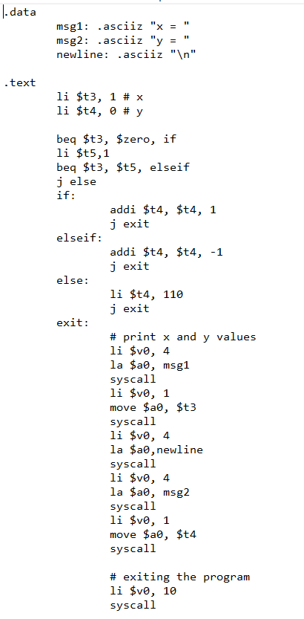

Result for x=0



Result for x=1



Result for x=10



1. Write a program to add first N odd numbers. The program should ask the value of N.

Ans.

Solution

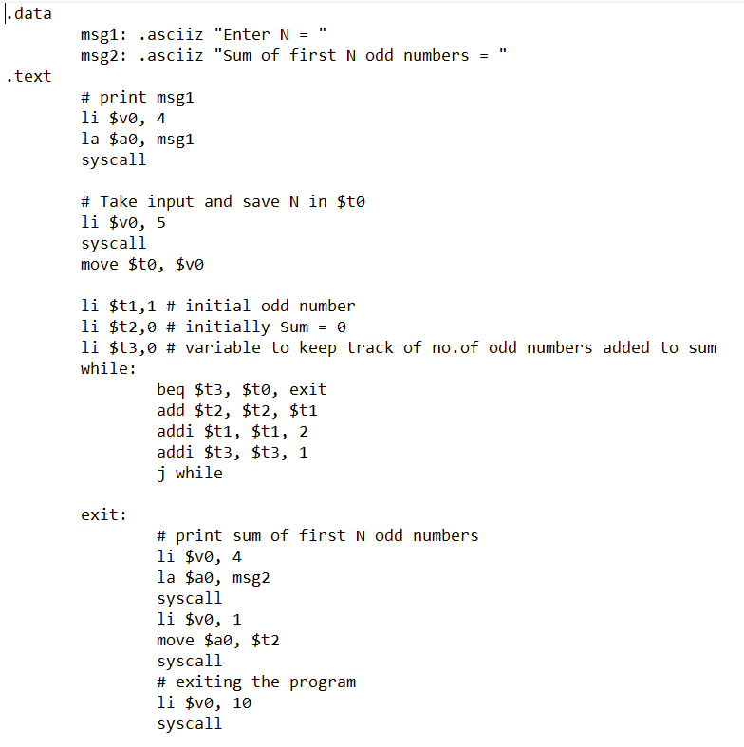

Output

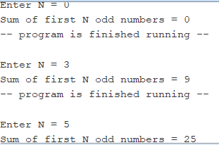

1. Write a MIPS program to find sum of squares of first N even numbers.

Ans.

Solution

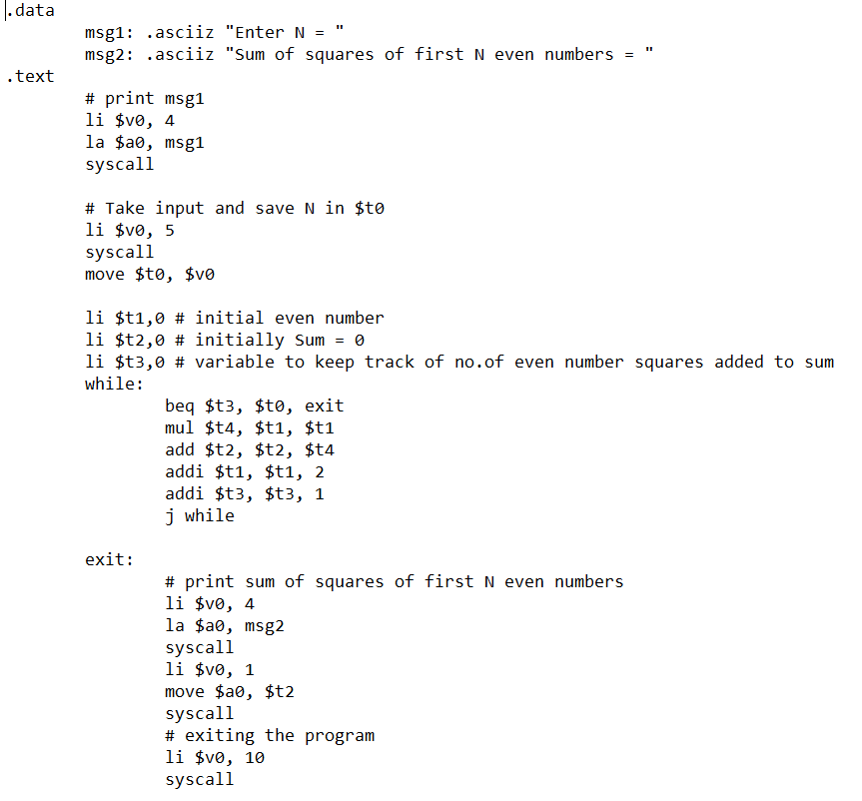

Result

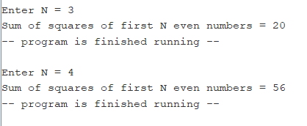

1. Write MIPS code to find length of an array. End of the array is marked by two cells with ’0’ value.

Ans.

Solution

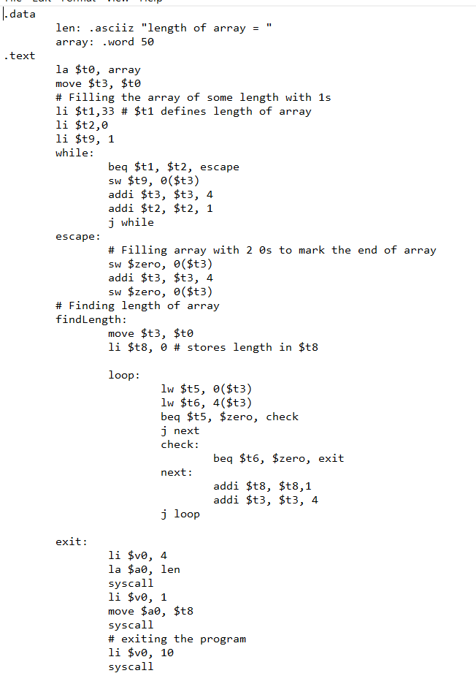

Output



